Parametric Redesign of Circular Re-Entrant Unit Cell for Tunable Negative Poisson’s Ratio

Jatin Sharma^{1 [0009-0004-6316-8406]}, Mansi Singh^{1 [0009-0006-1572-3780]}, Anshul Sharma^{1 [0000-0001-9313-9850]} and Rajnish Mallick^{2 [0000-0002-6433-606X]}

¹ Department of Mechanical Engineering, National Institute of Technology, Hamirpur, Himachal Pradesh, 177005, India
² School of Interdisciplinary Design and Innovation (SIDI), Indian Institute of Information Technology, Design and Manufacturing, IIITDM Kancheepuram, Chennai, 600127, India
anshulsharma@nith.ac.in

Abstract. The present work is focused to carryout the parametric design and mechanical behavior of redesigned auxetic unit cell CR-X. The modified design incorporates an additional internal structure having X-shape into the conventional circular re-entrant (CR) unit cell. The finite element based analysis approach using ANSYS platform was performed to understand the mechanical response of the lattice structures subjected to axial compressions at various strain levels. A parametric study with five different ligament thicknesses was also performed to see how they influence the auxeticity of the CR-X structures. All CR-X configurations under study demonstrated the auxetic behavior, in terms of the Poisson’s ratio and also offering higher strength compared to conventional CR structures. The results reveals that the values of negative Poisson’s ration (NPR) increases from -0.95 to -1.008 as the thickness of the ligaments decreases. The results also reveals that ligament thickness can play an important role in tuning the auxetic response of CR-X structures and optimizing deformation behavior which makes it a very good choice for mechanically responsive applications specially energy absorbing.

Keywords: Negative Poisson’s Ratio, Re-entrant, Finite Element Analysis

1. Introduction
Auxetic materials are widely known for their negative Poisson’s ration (NPR) have recently gained substantial focus around the globe owing to their deformation behavior and superior mechanical properties. In 1987, Lakes et al. [1] observed the phenomenon of auxeticity using a foam material which expanded laterally on applying tensile loads axially, which was opposite to conventional deformation behavior [2, 3]. This led to the discovery of auxetic structures, which are identified by their negative Poisson’s Ratio (NPR) [1]. Due to this distinctive deformation behavior, auxetic structures are gaining increasing demand across various engineering disciplines. Load-bearing systems [4], energy-absorbing components [5], and composite materials [6] used in structural engineering, biomedical engineering [7], and textile engineering [8] utilize applications of auxetic structures. Re-entrant [9], star-shaped [10], arrow-head [11], and chiral [12] configurations are the most widely studied auxetic Primitive Cells. To achieve enhanced mechanical performance and multifunctional properties [13, 14] efforts have been made by researchers towards developing hybrid auxetic structures by combining these conventional unit-cells.
Auxetic structures are kind of amazing because they have mechanical properties that are just way better than what normal materials offer. Things like how much better they are at resisting a sideways push (called shear strength), how hard it is to make a dent in them (indentation resistance), and how much they can handle before they actually crack or break (fracture toughness) [15]. They're also really good at soaking up hits and impacts (energy absorption capacity) and crushing in a very stable (stable plateau stress behavior), predictable way. Because they're so tough and shock-absorbing, we're seeing auxetic materials pop up everywhere. You can find them in parts for airplanes and spacecraft (aerospace) ,piezoelectric devices and in smart devices that measure pressure or strain , in high-tech fabrics , in medical devices like stents, and even in car bumper systems and protective sports gear [15].
One of the most promising uses is in auxetic honeycomb structures. These are super lightweight but also incredible at absorbing energy, which makes them perfect for safety systems on the road and in aerospace components. Moreover, researchers have found a way to make the classic honeycomb even stronger: instead of using straight connecting pieces, using curved elements [14] gives the structure even better shock-absorbing abilities, making these materials perfect for all sorts of demanding engineering tasks. However, the mechanical performance of conventional unit cells can be limited by stress concentration at ligament junctions and restricted tunability of deformation characteristics. To address these limitations, the present study is focused to tune the one of the prominent property, Poisson’s ratio, of the circular re-entrant (CR) unit cells by parametric redesign of the unit cell using finite element analysis. The integration of this internal reinforcement aims to improve structural stability while preserving auxetic functionality. Through finite element analysis (FEA) and a systematic parametric study involving variations in ligament thickness, the present research investigates the tunability of NPR and the deformation mechanisms governing the CR-X structure. This study contributes to the design of next-generation auxetic metamaterials with improved adaptability for engineering applications requiring controlled deformation and enhanced energy absorbing capabilities.

2. Methodology
2.1. Modeling of auxetic structure
In present study, the conventional re-entrant unit cell has been redesigned as circular re-entrant (CR) unit cells incorporated with X shape (CR-X) as illustrated in Figure 1. The conventional circular re-entrant is known for its high negative Poisson’s ratio (NPR) behavior and after redesigning by integrating a X shape of different ligament thickness (t), the Poisson’s ratio can be tuned for particular applications. The modeling of different unit cells under study was carried out using CATIA Platform. By arranging the three number of unit cells periodically along both X and Y directions, a 2D auxetic structure is obtained which was analyzed further.
Figure 1 (a) presents the geometric characteristics of the circular re-entrant (CR) unit cells incorporated with X shape (CR-X). The X-shaped unit cell is placed within conventional CR unit cell. Under the axial compressive, the X - shaped geometry facilitates rotational deformation and transverse contraction, resulting in an expected auxetic response characterized by negative Poisson’s ratio behavior. This design promotes more uniform stress distribution and stable deformation modes, leading to controlled Poisson’s ratio and enhanced mechanical performance. Table 1 presents the important geometric parameters for the construction of CR-X unit cell.

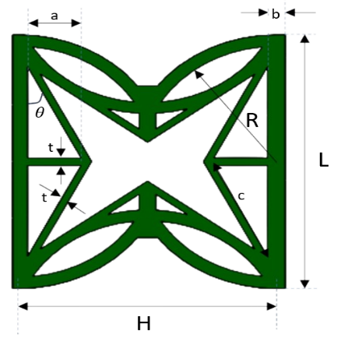
Y
X
(a)
(b)

Fig. 1. (a) Geometric properties of the circular re-entrant (CR) unit cells incorporated with X shape (CR-X) and (b) CR-X auxetic structure [16]

Table 1. Geometric parameters for CR-X unit cell [16]
L | H | R | a | b | c | $$θ$$
32.2 mm | 27.95 mm | 14.59 mm | 5.79 mm | 1.63 mm | 12.84 mm | 26.8॰
The relative densities CR unit cell and the CR –X unit cell are represented as [17]:
(1)
(2)

2.2. Mechanical properties of the material used for analysis
In this study, Acrylonitrile Butadiene Styrene (ABS) plastic was employed as the base material for the auxetic unit cells. Instead of conducting experimental tensile tests, the mechanical properties of ABS were sourced directly from the ANSYS Granta material Database integrated within ANSYS Workbench. This database provides standardized, validated material parameters, including Young’s modulus, Poisson’s ratio, tensile yield strength. The extracted material data were assigned to the finite element models and used consistently throughout all numerical simulations to predict the mechanical behavior of both conventional CR structure and its redesigned CR-X variant. Utilizing a well-established material database ensures uniformity, minimizes uncertainties arising from specimen preparation and testing and enhances the reproducibility of the numerical analysis.

2.3. Finite element analysis
In the performed analysis, the quasi-static compressive response of the CR-X and CR structure is analyzed using finite element analysis (FEA) in ANSYS Workbench. A Dynamic-Explicit analysis is performed. For the analysis, the lower part was fully fixed while the upper part was subjected to a displacement-controlled load (${-U}_{y})$. The mesh and boundary conditions for the CR-X structure are shown in Figure 2. The solid model was meshed using tetrahedral solid elements with a uniform element size 1.2 mm. Numerical analysis was carried out for five CR-X auxetic and one CR structure composed of the same CR-X and CR unit cells respectively but with different ligament thickness t, to assess the impact of varying thickness on the compressive result.

3. Result and Discussion
3.1. Evaluation of Auxetic Response
The Poisson’s ratio of the CR and CR-X auxetic structures was obtained from the finite element simulation by computing the axial and transverse strains during compression as [18, 19]:
(3)
where ε_{y} is the strain along the loading direction and ε_{x} ​is the strain measured perpendicular to the applied displacement.
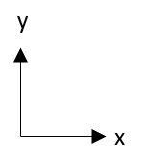
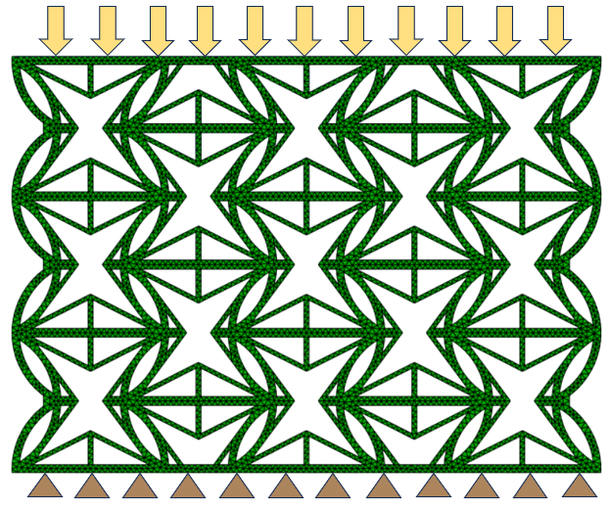
U _{y} = 0
Applied displacement (${-U}_{y}$)

Fig. 2. Applied boundary and loading conditions on CR-X structure.

In this study, the upper plate of the model was subjected to a displacement-controlled compressive load, while the lower plate was fully constrained. The horizontal displacement of a reference node located at the mid-span of the unit cell was used to evaluate the transverse strain, and the corresponding axial deformation was extracted from the applied vertical displacement. Poisson’s ratio for each structure was calculated at small deformation levels to ensure linear elastic behavior. This procedure was repeated for different strain rates to evaluate the effect of applied strain on the auxetic response. Figure 3 shows the progressive deformation of the CR-X and CR structures under compressive loading at different strains. The results reveals the distinct mechanical responses associated with their geometric configurations. As the applied strain increases, the CR-X structure (Figures 3 (a-e)) exhibits a characteristic inward folding and lateral expansion, consistent with its auxetic behavior. The deformation pattern evolves smoothly, demonstrating the structures ability to accommodate large compressive strains through rotation and bending of the re-entrant members. The results also reveals the differences the in structural adaptability, indicating that the geometric modifications in CR-X enhances its capacity for uniform deformation and auxetic response under increasing compressive strains compared to CR structures.
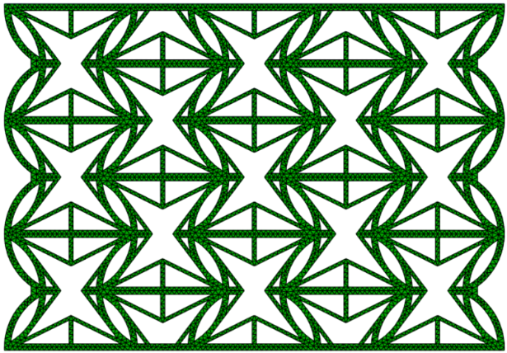
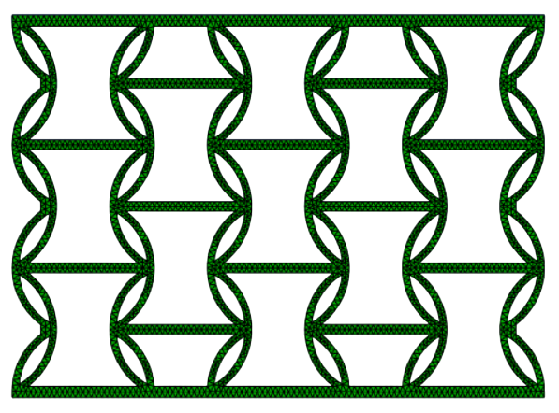
(a)
(f)
at ε = 0

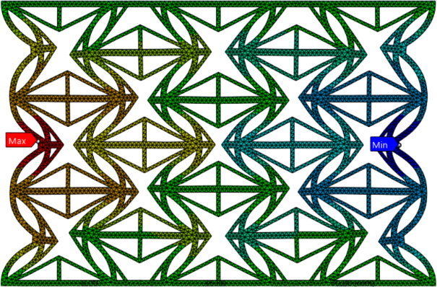
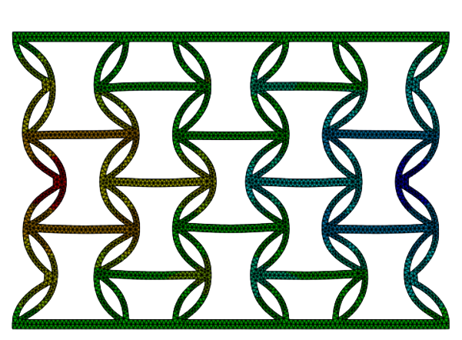
(b)
(g)
at ε = 0.05

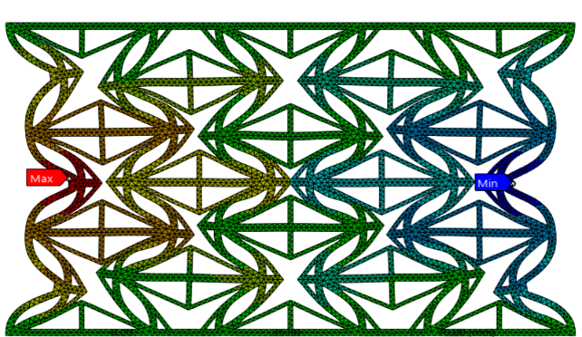
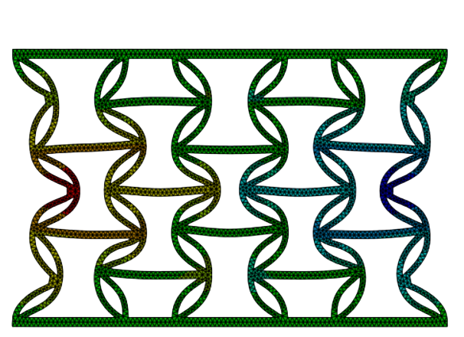
(c)
(h)
at ε = 0.1

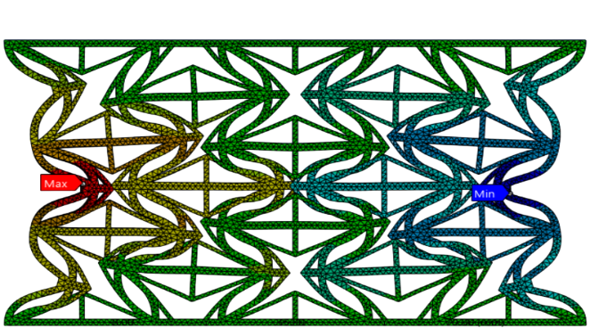
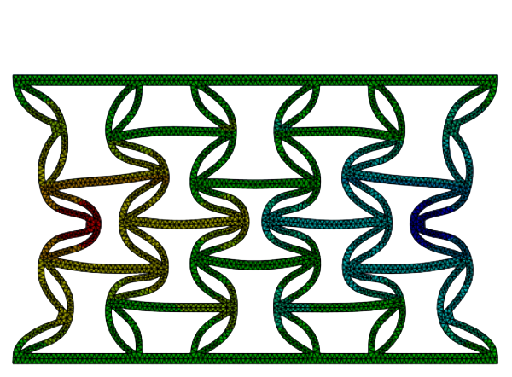
(d)
(i)
at ε = 0.2

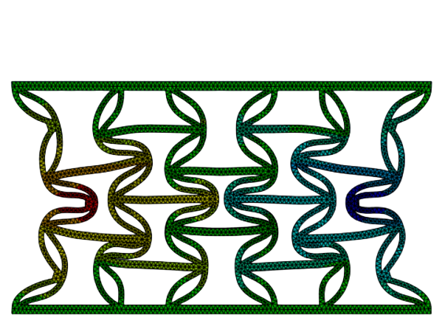
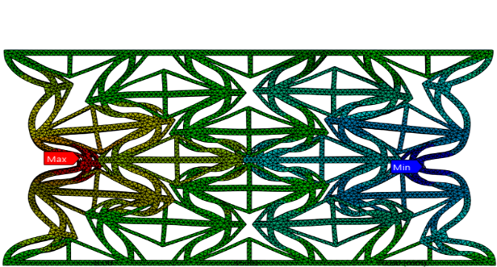
(e)
(j)
at ε = 0.25

Fig. 3. Progressive deformation of (a-e) CR-X and (f-g) CR structures under compressive loading at different strains

Table 2 presents the computed Poisson’s ratio for both the modified CR-X unit cell structure and the conventional circular re-entrant (CR) unit cell structure across different applied strains. The results confirm that both designs consistently exhibit NPR behavior throughout the loading range, validating their auxetic characteristics. However, a clear distinction is observed between the two geometries as CR structure demonstrates more NPR values compared to CR-X structure. The embedded X-shaped internal geometry increases internal stiffness and restricts excessive lateral deformation, leading to a slightly reduced auxetic response. This geometric reinforcement via X-shaped feature offers improved structural stability at the cost of slightly lower NPR values. This trade-off suggests that the CR-X design may be particularly advantageous in applications requiring both auxetic behavior and enhanced mechanical robustness.
Table 2. Variation of Poisson’s ratio of the CR-X and CR structures at different applied stains under axial compression
ε | 0.05 | 0.1 | 0.2 | 0.25
ν_{xy} (CR – X) | -1.25 | -1.1 | -1 | -0.94
ν_{xy} (CR) | -1.65 | -1.53 | -1.4 | -1.21

3.2. Influence of Ligament Thickness (t) on mechanical response of CR-X structure
The auxetic behavior of the CR-X structure was evaluated in previous section and compared with conventional CR structure. A parametric analysis was conducted to tune Poisson’s Ratio with varying ligament thickness (t). The tuning of the NPR can be utilized for different application requirements. For parametric study, five different ligament thickness (t = 1.85, 1.55, 1.25, 0.85 and 0.65 mm) were used without changing any other parameters to maintain uniformity. Figure 4 illustrates the effect of ligament thickness (t) on CR-X structure’s Poisson’s ratio. All CR-X configurations under study demonstrated the auxetic behavior, in terms of the Poisson’s ratio and also offering higher strength compared to conventional CR structures. The results reveals that the values of negative Poisson’s ration (NPR) increases from -0.95 to -1.008 as the thickness of the ligaments decreases. This indicates that CR-X structure with thinner ligaments demonstrates stronger auxetic characteristics due to higher bending and rotational flexibility. On the other hand, the higher bending stiffness of thicker ligaments limits the lateral expansion.





t = 0.65
$ν$ = - 1.008
ρ = 0.637
t = 0.85
$ν$ = - 1.003
ρ = 0.612

t = 1.25
$ν$ = - 0.996
ρ = 0.688

t = 1.55
$ν$ = - 0.97
ρ = 0.727

t = 1.85
$ν$ = - 0.95
ρ = 0.764

Fig. 4. : Effect of ligament thickness (t) on CR-X structure’s Poisson’s ratio

3.3. Deformation Mechanism
We observe variation in Poisson’s ratio because of the changes in the ligament thickness of the CR-X unit cell. With higher ligament thickness (t = 1.85 mm), the structure possesses more bending resistance which in turn restricts motion at joints of the unit cell. Therefore axial compression gives less lateral contraction as compared to that of a unit cell with thinner ligament. Thinner ligaments have less bending resistance, therefore does not restrict motion at the joints too much and allows cell walls to fold inward easily under compression. This shows that unit cells with thinner ligaments will deform more as compared to the unit cells with thick ligaments, giving a large value of negative Poisson’s ratio. Therefore, we can achieve strong auxetic nature by making little changes in the geometry alone, without altering material properties.

4. Conclusion
This work presents the parametric design and mechanical evaluation of a modified auxetic geometry, termed the CR-X unit cell, developed by integrating X – shaped internal structure into conventional circular re-entrant (CR) unit cell. The behavior of the CR-X auxetic structure was investigated using an explicit dynamic solver based on finite element analysis. The Poisson’s ratio was computed from the axial and transverse strains obtained from numerical analysis, confirming that the modified geometry retains its auxetic characterstics. To evaluate the influence of geometry on auxetic performance, five different ligament thicknesses (t = 1.85, 1.55, 1.25, 0.85, and 0.65 mm) were analyzed while keeping all other parameters constant. The results indicate that all CR-X configurations exhibit a NPR demonstrating consistent auxetic behavior across the thickness range. The results are reveals that to obtain higher NPR values, the thickness of the ligament needs to be thinner. Thinner the ligament will be, more will be the deformation in the structure owing to more flexibility and moment based deformation which is more prominent. Approximately 7% increase in the NPR value is observed for thinner ligaments compared to thicker ligaments under study. . The results also reveals that ligament thickness can play an important role in tuning the auxetic response of CR-X structures and optimizing deformation behavior which makes it a very good choice for mechanically responsive applications specially energy absorbing. Integrating X-shape with conventional CR results in stiffer structure with reduced auxetic characteristics. However, this reinforment to CR structures provides more structural stability with marginally reduced NPR value.

Acknowledgement
The authors acknowledges the Anusandhan National Research Foundation (ANRF) to financially support the work under MATRICS Scheme, File No.: MTR/2023/000835 and MTR/2022/001029.

References
[1] Lakes, R.: Foam structures with a negative Poisson’s ratio. Science 235, 1038 (1987).
[2] Jiang, W., et al.: Manufacturing, characteristics and applications of auxetic foams: a state-of-the-art review. Composites Part B: Engineering 235, 109733 (2022).
[3] Luo, C., et al.: Design, manufacturing and applications of auxetic tubular structures: a review. Thin-Walled Structures 163, 107682 (2021).
[4] Etemadi, E., et al.: Load-bearing characteristics of 3D auxetic structures made with carbon fiber reinforced polymer composite. Composite Structures 2023, 117206 (2023).
[5] Nasim, M.S., Etemadi, E.: Three-dimensional modeling of warp and woof periodic auxetic cellular structure. International Journal of Mechanical Sciences 136, 475–481 (2018).
[6] Momoh, E.O., et al.: A state-of-the-art review on the application of auxetic materials in cementitious composites. Thin-Walled Structures 196, 111447 (2024).
[7] Abbaslou, M., Hashemi, R., Etemadi, E.: Novel hybrid 3D-printed auxetic vascular stent based on re-entrant and meta-trichiral unit cells: Finite element simulation with experimental verifications. Materials Today Communications 35, 105742 (2023).
[8] Zeeshan, M., Hu, H., Etemadi, E.: Geometric analysis of three-dimensional woven fabric with in-plane auxetic behavior. Polymers 15(5), 1326 (2023).
[9] Usta, F., Scarpa, F., Türkmen, H.S.: Edgewise compression of novel hexagonal hierarchical and asymmetric unit cells honeycomb metamaterials. Materials Today Communications 24, 101102 (2020).
[10] Logakannan, K.P., et al.: Stiffened star-shaped auxetic structure with tri-directional symmetry. Composite Structures 279, 114773 (2022).
[11] Chen, Y.-L., Wang, X.-T., Ma, L.: Damping mechanisms of CFRP three-dimensional double-arrow-head auxetic metamaterials. Polymer Testing 81, 106189 (2020).
[12] Hu, C., et al.: 3D printing of chiral carbon fiber reinforced polylactic acid composites with negative Poisson’s ratios. Composites Part B: Engineering 201, 108400 (2020).
[13] Zhang, W., et al.: On in-plane crushing behavior of a combined re-entrant double-arrow honeycomb. Thin-Walled Structures 2023, 111303 (2023).
[14] Etemadi, E., Hu, H., Hosseinabadi, M., Taghizadeh, M., Scarpa, F.: Enhancing the energy absorption capability of auxetic metamaterials through auxetic cells within re-entrant circular units. Engineering Structures (2024).
[15] Shi, D., Wang, Z., Li, Y., Huo, R., Zhang, J., Cai, J.: A novel re-entrant circular star-shaped auxetic honeycomb with enhanced energy absorption and anisotropic Poisson’s ratio. Engineering Structures (2024).
[16] Zhang, X., Lu, G., You, Z.: Energy absorption of auxetic materials under compressive loading. International Journal of Mechanical Sciences 52, 527–533 (2010).
[17] Yang, W., et al.: Review on auxetic materials. Journal of Materials Science 39, 3269–3279 (2004).
[18] Imbalzano, G., et al.: A numerical study of auxetic honeycombs for energy absorption applications. Composite Structures 135, 1–12 (2016).
[19] Attard, D., Grima, J.N.: Modelling of hybrid auxetic structures. Physica Status Solidi B 249(7), 1330–1341 (2012).

